Stage 8 – Practicing Should Be Fun And Challenging
COURSE DESIGNER: Mitch Gibson (2025 Oklahoma Section Championship)
SCORING: Comstock 11 rounds.
TARGETS: 4 cardboard targets, 4 steel targets
SCORED HITS: 2 Best hits per carboard will be scored.
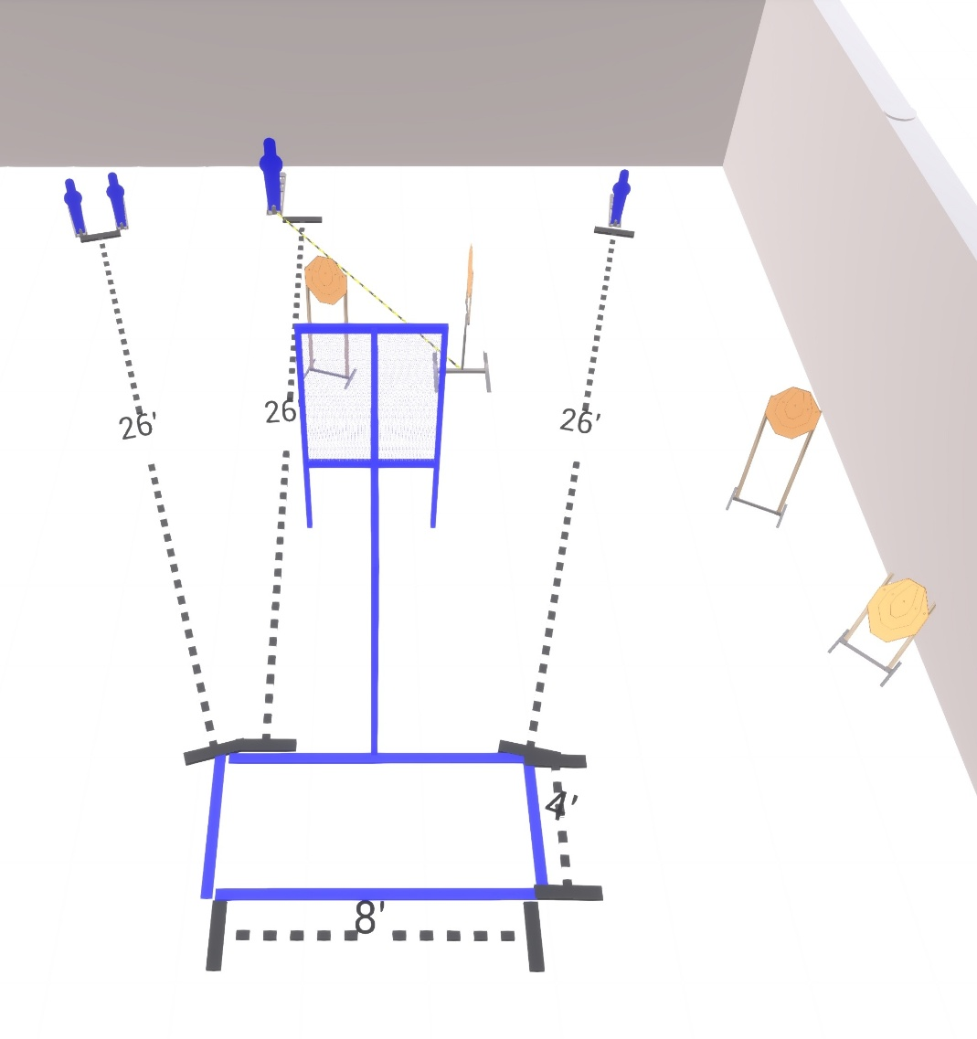

Written Stage Briefing:

Stage 8 – Practice Should Be Fun And Challenging - is a 12 round, 60 point, Comstock Course. There are 4 cardboard targets and 4 steel targets. The best 2 hits per cardboard will be scored.

Starting anywhere inside the shooting area.

Handgun is loaded and holstered, wrists below belt.
PCC is loaded held in both hands, stock on belt.

On the audible start signal, engage targets from within the shooting area.

Popper 2 activates the drop turn target which is not visible at rest.

USPSA / NROI Range Commands:
- Make Ready
- Are you ready?
- Standby
- If finished, unload and show clear
- If clear, hammer down and holster (Handgun)
If clear, hammer down and flag (PCC)
If clear, cylinder closed and holster (Revolver)
- Range is clear

Setup Notes:
4 Single Wall Stands
1 Full Wall
1 Half Wall
3 Target Stands / 6 target sticks
1 45 Degree Target Stand / 2 target sticks
1 Large Activator Popper
3 Small Popper + bases
1 Drop Turn Target + activation cables
